# CS 255 System Design Document Template

## UML Diagrams

### UML Use Case Diagram - System Overview

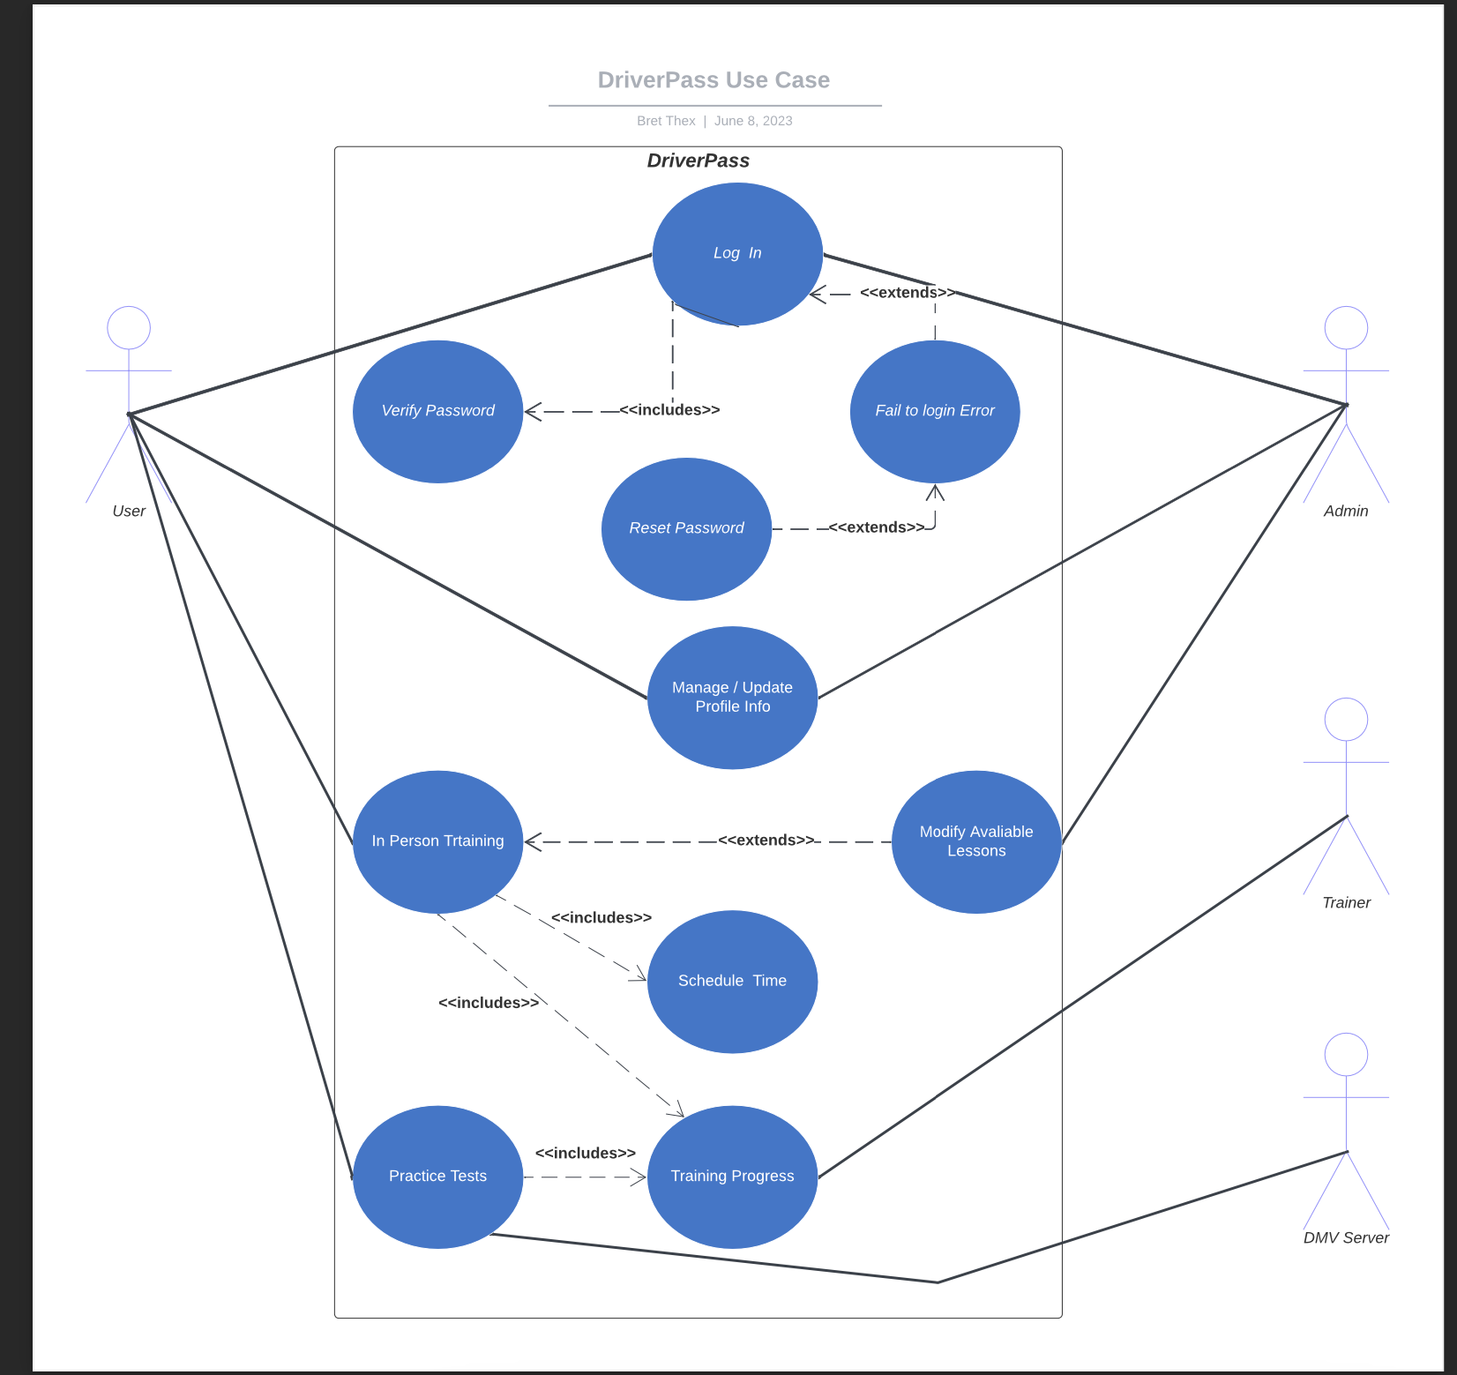

### UML Activity Diagrams - Schedule In-Person Training, Rest User Password

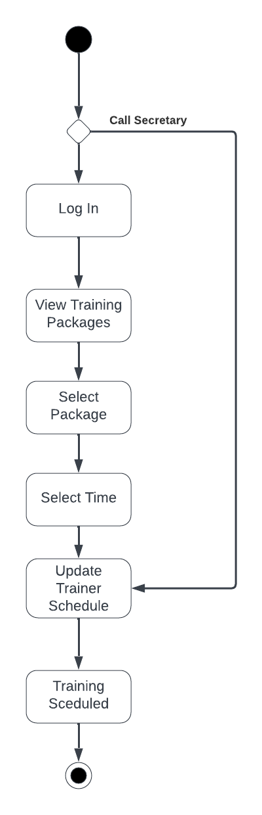

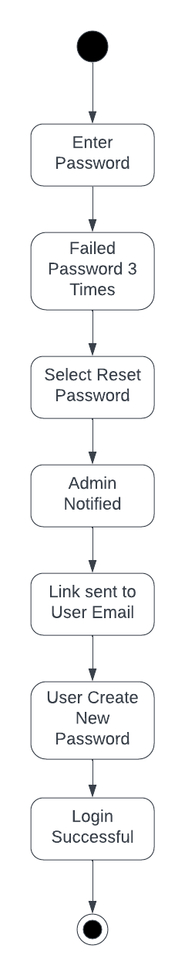

### UML Sequence Diagram - Schedule In-Person Training

### 

### UML Class Diagram

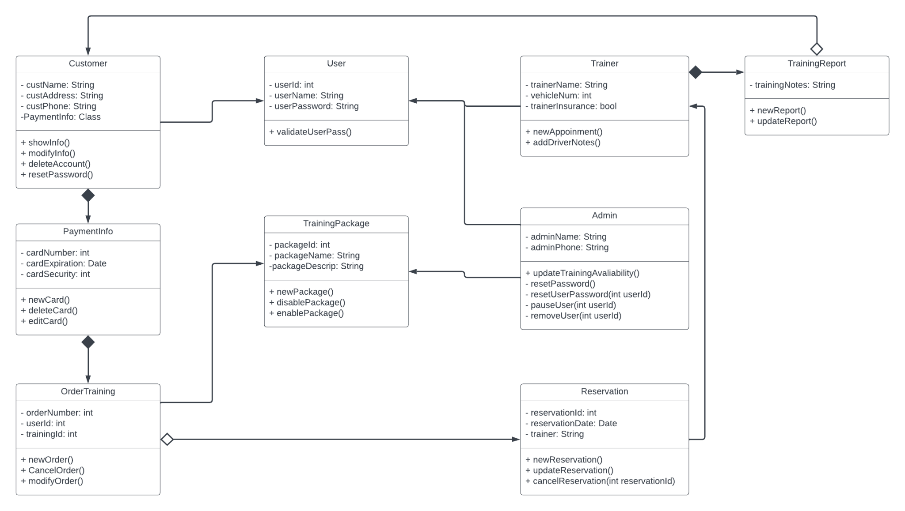

## Technical Requirements

DriverPass Requirements

DriverPass is cloud hosted so there are no requirements for a physical server. They will need internet access and a computer to access the cloud host's website to manage server size and updates. For development purposes, DriverPass will need a computer with access to development software such as Eclipse.

User Requirements

With DriverPass being a web-based application the user requirements are minimal. The user only needs a computer with a browser and internet access.